Investment Analysis of Purchasing a Paint Sprayer

Matthew Newman, Mohammed Mustafawi, Taylor Moors

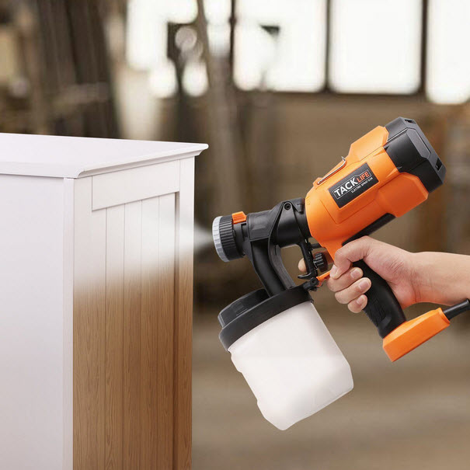

# 

# Introduction

Paint sprayers are a device for distributing paint (pictured above) and at the job site they are essential to coating both exterior and interior finishes of a house. The sprayer is capable of saving vast amounts of time and labor needed to cover large areas. With the widespread dispersion of the paint leaving the device, it is the easiest method to complete the task at hand. Other methods such as using a roller, or a brush, always take much longer because they coat smaller areas due to their much smaller widths. At Cahill Painting Company (CPC), there are normally two to four workers on a specific job site at a time. Even with four workers using rollers and/or brushes, the rate of production is slower than that of the paint sprayer. Because of this, CPC is interested in purchasing a replacement paint sprayer for painting the exterior of houses. CPC wants to make sure that the company is making the most economical choice when it comes to paint sprayers and that money is not spent unnecessarily on a product that isn’t being used effectively. We are also going to evaluate our Sprayer on the risks associated with purchasing it and whether climate change is going to have a significant impact on the costs. In order to complete an economic analysis for this situation, CPC has provided standard data such as minimums and maximums regarding their day-to-day operations. With the minimum and maximum data, for analysis the average of these values was typically used in most cases.

# Objective

The overall objective of this project is to evaluate whether or not purchasing a paint sprayer is both an economical and environmentally friendly option for CPC. To make the right decision surrounding this investment we have the following objectives to analyze this situation:

1. Analyze the effects of Before and After Tax Cash Flows on the company
2. Determine minimum sales required to justify the investment with a Break-Even After Tax analysis
3. Determine the impact of specific investment parameters by completing a Sensitivity After Tax Analysis
4. Incorporate random variation surrounding the investment typically due to real world errors by completing a Risk Analysis After Tax
5. Exploring the effects the investment may have on Climate Change

# Data Collection

View the Final Project Data.xlsx Data page for a complete run-down of the data that was used in this assignment.

Below is the time frame and profits associated with tasks. This information will then be used to calculate how much profit the company is able to bring in annually for painting people’s houses.

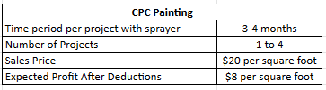

***Fig1. CPC painting Data***

After obtaining those values we can then calculate both the average yearly income and the maximum and minimum profit for each year. This is based off of a 2000 square foot house which is the average in the US.

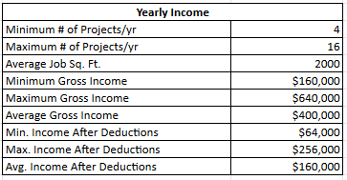

***Fig2. Average, Minimum, and Maximum variables for project***

In order to calculate the O&M cost of purchasing a sprayer vs painting by hand we had to estimate the length of time that it would take to paint the 2000 square foot house with and without the sprayer. Not only does painting by hand take more time to complete but it also costs more per day in labor due to it requiring hire skilled work.

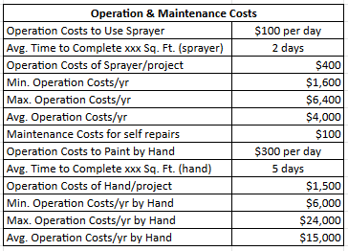

***Fig3. Operation and maintenance data***

All that leaves in terms of data is to find the price and salvage value of the sprayer. We found a suitable option from Sherwin Williams. We also assumed a MARR of 10%.

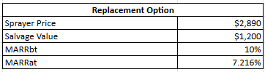

***Fig4. Displays Sprayer purchase and resale price, as well as MARR values***

# After Tax Cash Flow Analysis

View the Final Project Data.xlsx ATCF page for a complete run-down of the After Tax Cash Flow Analysis.

Below is the After Tax Cash Flow analysis for the company if they were to purchase the sprayer. We used 5 Years MACRS Depreciation in order to calculate the write off. The operating and maintenance cost of using a paint sprayer is significantly lower than the cost associated with painting by hand, but it is still much higher than the cost of purchasing a sprayer. This means that the actual physical cost of buying a sprayer isn’t going to matter much compared to the O&M and income. We see this later as well when we perform a sensitivity analysis.

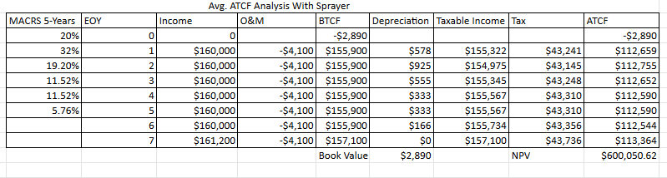

***Fig5. Displays ATCF analysis of Avg. number of projects with sprayer***

Below is the After Tax Cash Flow analysis if the company wasn’t going to purchase the paint sprayer. The O&M cost of painting without a sprayer is approximately 3.7 times higher, easily making the $2890 upfront cost of the sprayer worthwhile. The value of these investments are still very similar however due to the fact that the profits that the business is bringing in are very high compared to the operating and maintenance costs.

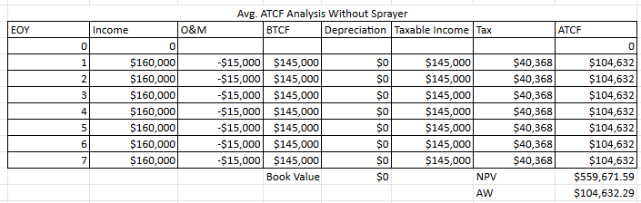

***Fig6. Displays ATCF analysis of Avg. number of projects without sprayer***

# Break Even Analysis

View the Final Project Data.xlsx Break-Even page for a complete run-down of the Break Even analysis.

We ran 3 different Break Even analysis controlling for the Price of the sprayer, Operation and maintenance costs, and income generated. Below are our values when adjusting for the price of the sprayer. The sprayer would have to cost $26,347 in order for it to no longer be an economically viable option. This is an order of magnitude more expensive than the price that the sprayer actually costs.

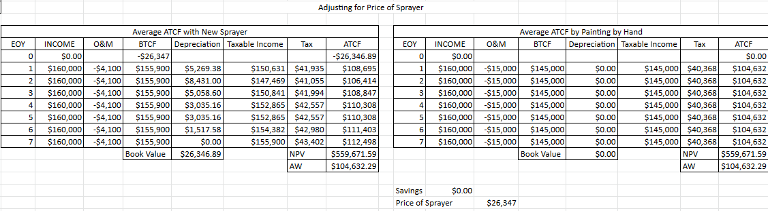

***Fig7. Break Even analysis changing price of sprayer***

Below is our Break Even analysis when adjusting for the operating and maintenance cost of the sprayer. The O&M costs would have to be $10,117 a year in order to make it no longer economically viable compared to painting by hand.

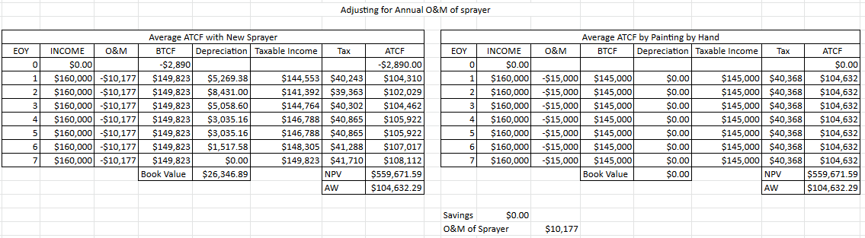

***Fig8. Break Even analysis changing O&M costs***

The final Break Even analysis that we performed was adjusting for annual income. In order for it no longer be economically viable to select these investment options it would have to be less than $8925 for the investment with the sprayer and $15,000 for the painting by hand option.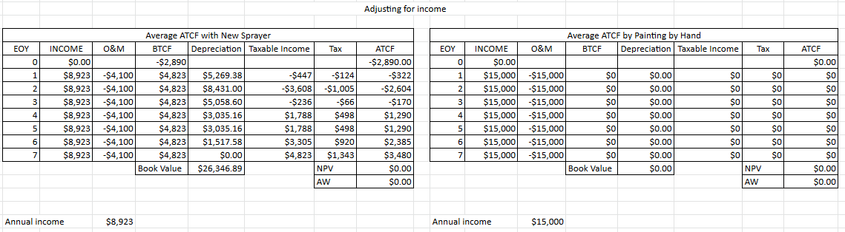

***Fig9. Break Even analysis changing generated annual income***

# Sensitivity Analysis

View the Final Project Data.xlsx Sensitivity page for a complete run-down of the Sensitivity analysis.

The biggest contributing factor that affected the value of the investment was how much income the company brought in. This held true for both investing in a paint sprayer and painting by hand. The cost of the sprayer and operation and maintenance didn’t have nearly as large of an impact on the value of the investment.

Pictured below are our results for the NPV for investment with the sprayer.

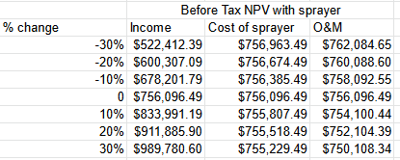

***Fig10. Displays before tax net present value of CPC whilst using sprayer***

Here are our results visualized in a graph. The cost of the sprayer and annual operation and maintenance both have a similar negative correlation with the value of the investment.

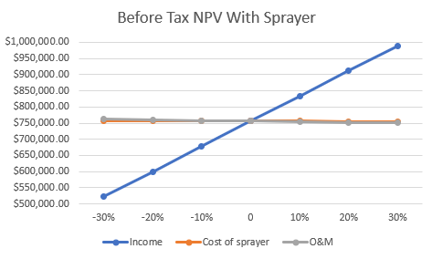

***Fig11. Sensitivity analysis with sprayer***

Below are our results for adjusting the income and operation and maintenance if we were to just paint by hand. Adjusting for income has a much larger effect on the value of the investment then annual maintenance costs.

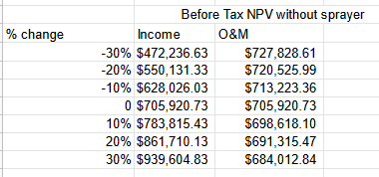

***Fig12. Displays before tax net present value of CPC without sprayer***

Finally below we have those results represented visually. Both the investment with purchasing a paint sprayer and without purchasing one have very similar sensitivity curves, so purchasing a paint sprayer isn’t inherently more risky than not purchasing one.

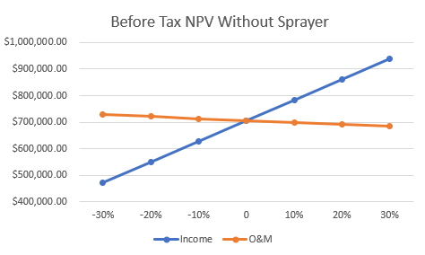

***Fig13. Sensitivity analysis with sprayer***

# Monte-Carlo Simulation

In this section a Monte Carlo simulation is utilized in order to account for any variance from external factors that might hinder or enhance the economic performance of Cahill Painting Company (CPC). The simulation generates a set of random values for the average annual worth of CPC given certain parameters, over a set number of trials, in this case 1000 simulations are utilized. Average annual worth was found to be equal to $112,181.27 for use of a sprayer for painting, whilst the average AW according to the Monte Carlo simulation has a similar value of $113,636.50. The simulation also displays that Cahill Painting Company faces a risk of 0.30% for having a negative annual worth, which is a pretty favorable result.

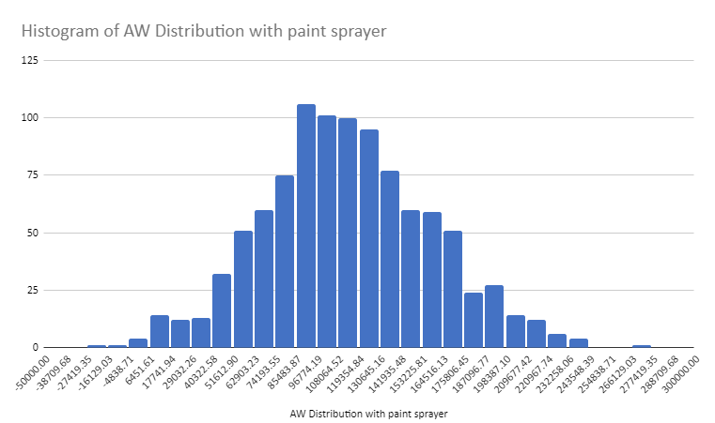

***Fig14. Displays AW distribution of CPC utilizing paint sprayer***

A Monte Carlo simulation is also used to find the average annual worth of CPC without use of a paint sprayer. Utilizing the ATCF method, average AW of CPC without use of a sprayer was calculated to be equal to $104,632.29, whilst it was found to be equal to $105,678.35 utilizing the average of the 1000 simulation trials. The company faces a risk of 1.00% of facing a loss in an annual term without the use of a paint sprayer, which is larger than the risk faced for using a sprayer for their projects. The Monte Carlo simulation does have more variance in values, but will offer a more realistic value given some factors like inflation, market performance, competition, or new technology that might account for some randomness in expected values.

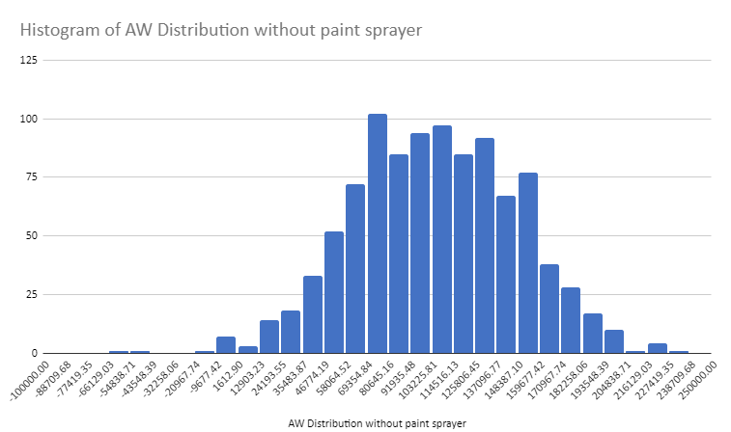

***Fig15. Displays AW distribution of CPC without using paint sprayer***

# Climate Change Impact

In doing research on the Graco FinishPro II 295PC Air-Assisted Sprayer, there were no climate impact implications to be made when looking into the specifications of the product. The product does not operate with the use of a fuel tank. Instead, it is capable of spraying the paint with the use of compressed air. A bucket is filled with paint, then the sprayer is placed for the suction tube to dip down into the paint. Then with the use of the pressurized air, the paint is dispersed through the hose onto the surface that CPC is working on. While this requires some electric power to do, the product specifications did not specify the usage of electricity for the machine. If there were a way to figure out the electrical output, then there could have been something to work with as far as accurately looking into the environmental impact that this sprayer may have.

# Conclusion

The objective of the analyses performed throughout this project is to determine the most economical decision for CPC in regards to investing in a paint sprayer. After completing each of the analyses mentioned above, it has been determined that investing in the paint sprayer is the best option. After doing an After Tax Cash Flow analysis the net present worth was significantly higher using a sprayer opposed to painting by hand.

When looking at the two options: paint sprayer or painting by hand, the Sensitivity Analysis helped determine that the yearly income is what affected outcomes of the net present worth and annual worth of the analyses. This could be clearly seen knowing the rate of production using a sprayer is much higher than the alternative by hand. A higher income will yield higher net present values and annual worths in each case. Since the rate of income for the business typically will always be higher than the operation and maintenance costs, this is what is most expected after completing the Sensitivity Analysis.

CPC should invest in the paint sprayer because it will rapidly increase the rate of work being completed. Since a project takes two days to complete with the sprayer, and five days to complete a project by hand, the overall income for the company will increase quicker. Thus, the annual worth and net present values will always exceed the corresponding worths when completing projects by hand. The assumption that annual and present worths of utilizing a paint sprayer is more profitable for CPC is also confirmed by our calculations for all variables analyzed.

# 

# Appendix

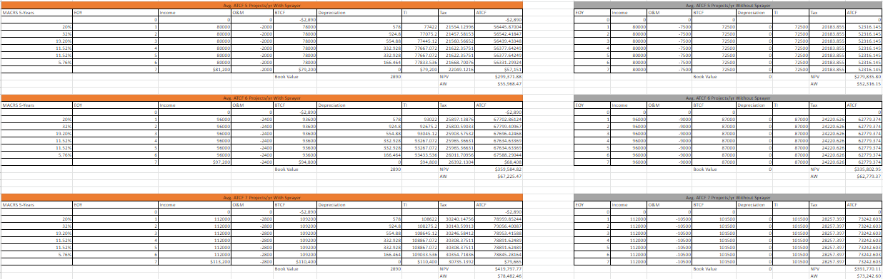

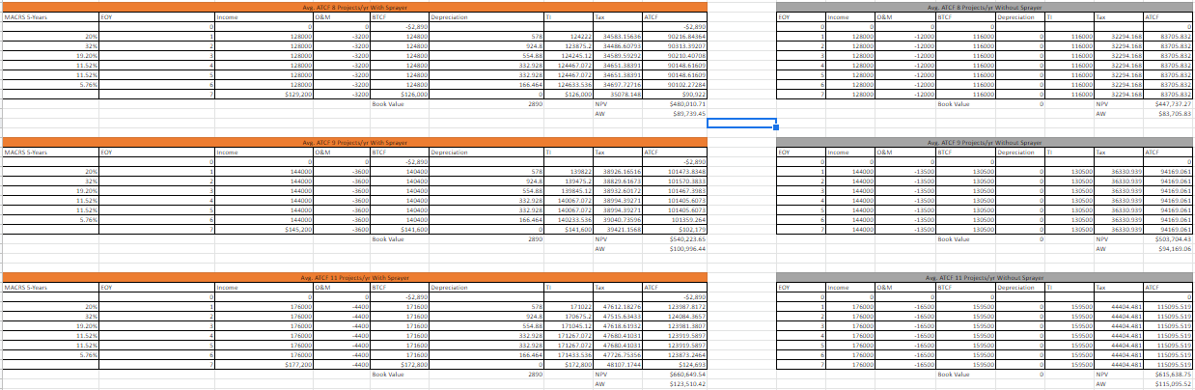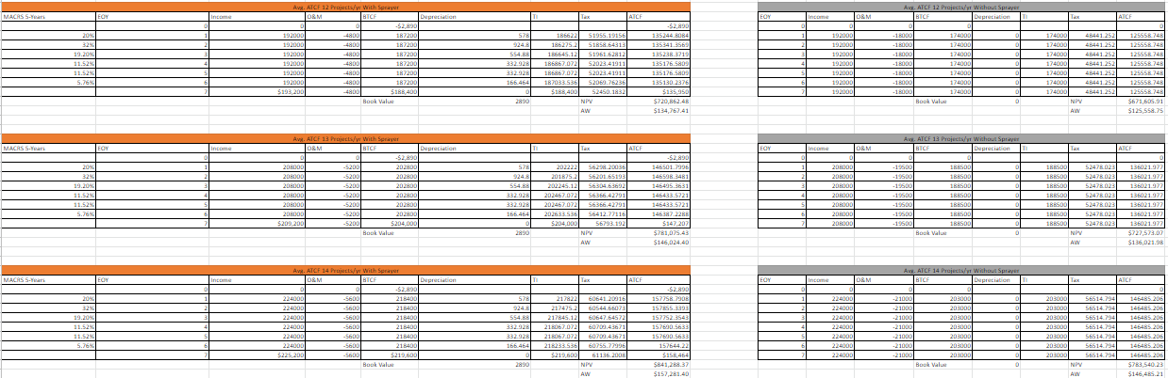

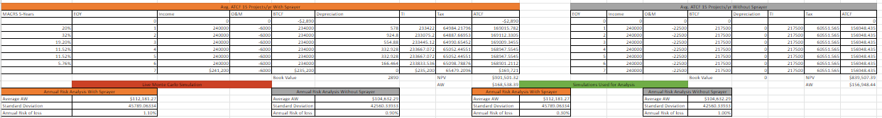

***Fig 16. ATCF analysis of CPC for 5-15 projects per year***

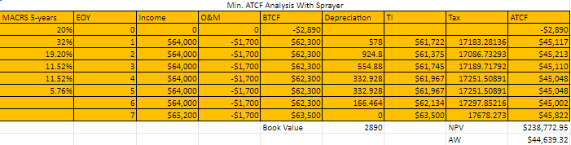

***Fig17. ATCF analysis for Min amount of projects(4 projects per year) with paint sprayer***

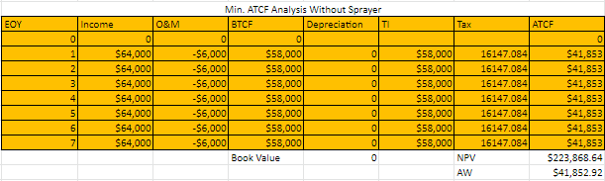

***Fig18. ATCF analysis for Min amount of projects(4 projects per year) without paint sprayer***

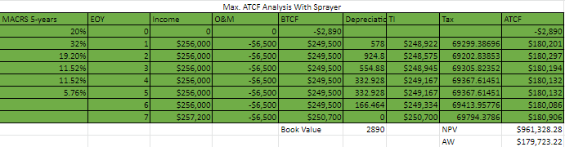

***Fig19. ATCF analysis for Max amount of projects(10 projects per year) with paint sprayer***

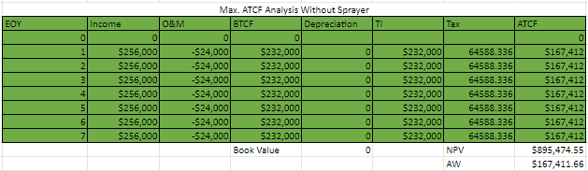

***Fig20. ATCF analysis for Max amount of projects(16 projects per year) without paint sprayer***

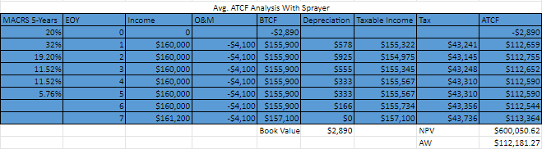

***Fig21. ATCF analysis for Avg. amount of projects(10 projects per year) with paint sprayer***

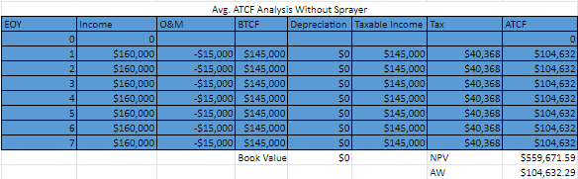

***Fig22. ATCF analysis for Avg. amount of projects(10 projects per year) without paint sprayer***

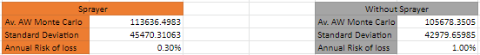

***Fig23. Summary of Monte Carlo Simulation Results***

# References

* About the author: Tina Orem is NerdWallet's authority on taxes and small business. Her work has appeared in a variety of local and national outlets. Read more. (n.d.). *2021-2022 federal income tax brackets & tax rates*. NerdWallet. Retrieved December 2, 2021, from <https://www.nerdwallet.com/article/taxes/federal-income-tax-brackets>.
* *Wage tax (employers): Services*. City of Philadelphia. (n.d.). Retrieved December 2, 2021, from https://www.phila.gov/services/payments-assistance-taxes/business-taxes/wage-tax-employers/.
* *Graco finishpro II 295 air-assisted airless sprayer*. Portland Compressor. (n.d.). Retrieved December 2, 2021, from https://www.portlandcompressor.com/store/graco-finishpro-ii-295-air-assisted-airless-sprayer.